SOLVING SIMULTANEOUS EQUATIONS GRAPHICALLY
Pearson Edexcel - Monday 8 June 2020 - Paper 3 (Calculator) Foundation Tier

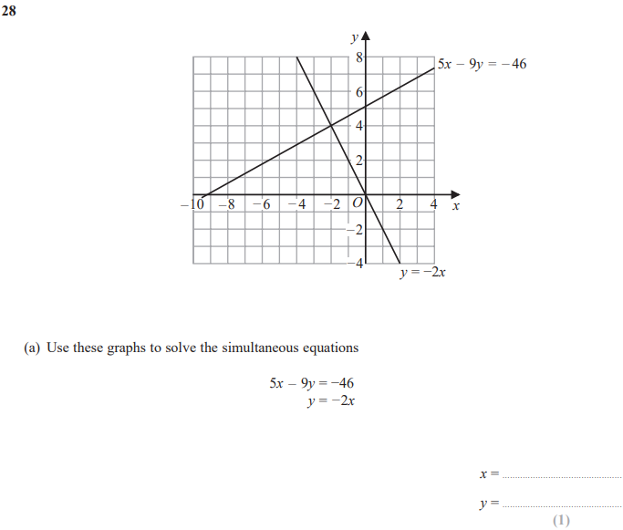
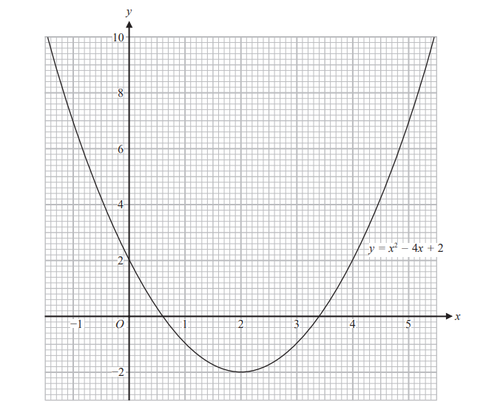

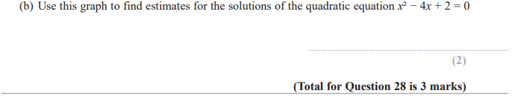

OCR Tuesday 5 November 2019 – Morning (Calculator) Foundation Tier
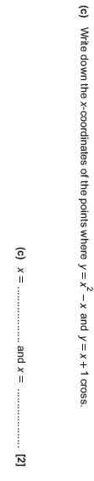
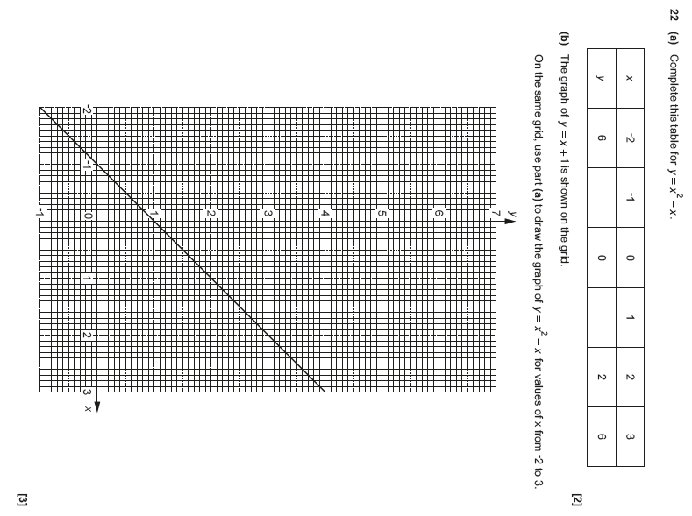

OCR Thursday 07 November 2019- Morning (Non-Calculator) Foundation Tier

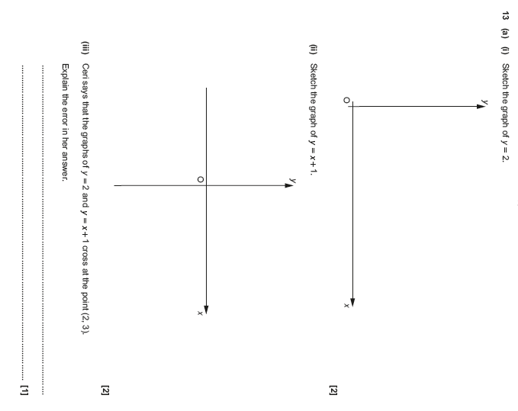

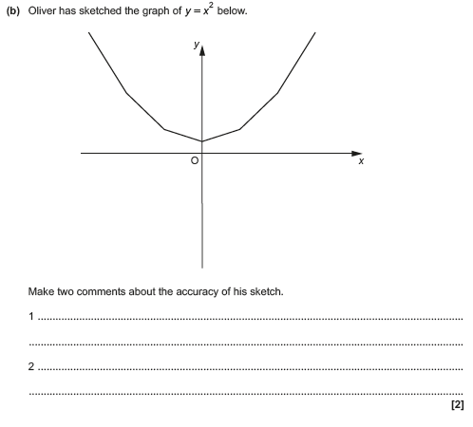

OCR Tuesday 11 June 2019 – Morning (Calculator) Foundation Tier
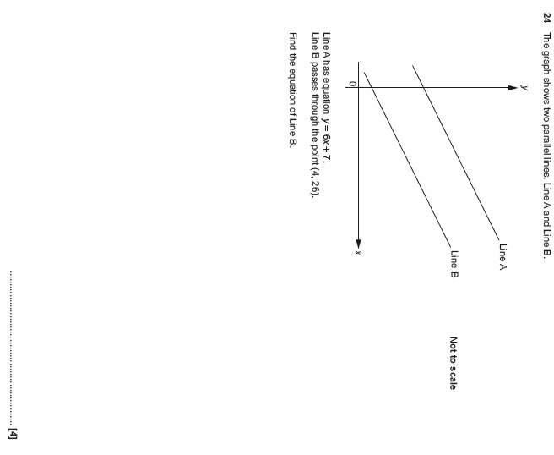

AQA Sample Paper 1– Morning (Non-Calculator) Foundation Tier

